• **The aim of this assignment is to develop a book reservation web site using PHP and MySQL database. The application will allow users to search for and reserve library books. Specifically, the application will enable the following:**

• **Deadline: 1st of December at 1pm. Demo start from 1pm.**

* Library functionality- the users should be allowed to:

· Search for a book

· Reserve a book

· View all the books that they have reserved

* *Login* – The user must identify themselves to the system in order to use the system and throughout the whole site. If they have not previously used the system, they must register their details.
* *Registration* - This allows a user to enter their details on the system. The registration process should validate that all details are entered. Mobile phone numbers should be numeric and 10 characters in length. Password should be six characters and have a password confirmation function. The system should ensure that each user can be identified using a unique username.
* *Search for a book*: The system should allow the user to search in a number of ways:
  + by book title and/or author (including partial search on both)
  + by book category description in a dropdown menu (book category should retrieved from database)
* The results of the search should display as a list from which the user can then reserve a book if available. If the book is already reserved, the user should not be allowed to reserve the book.
* *Reserve a book* – The system should allow a user to reserve a book provided that no-one else has reserved the book yet. The reservation functionality should capture the date on which the reservation was made.
* *View reserved books* – the system should allow the user to see a list of the book(s) currently reserved by that user. User should be able to remove the reservation as well.

**Notes:**

Apart from HTML, you should try to use other client side technologies like cascading style sheets to make pages neat and tidy. All validation should be server-side.

Do not allow for more than 5 rows of data per page, where search results are being displayed. Include functionality to display lists across more than one page.

The screens should be neat, simple design and usable. They do not need to be overly elaborate in presentation as you will not get extra marks for this.

**Other requirements**

* You must create/duplicate the database given in this document. You can add more data as you need to the tables.
* Use a common header and footer for your pages throughout the application
* Avoid hard-coding in your programs
* Include error checking as appropriate

**Database**

The book database contains four tables:

1. Users table - to hold user registration and password details. Each user is uniquely identified by a user name.

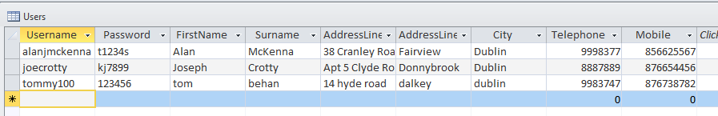

1. Books table - holding all book details, indexed by ISBN number

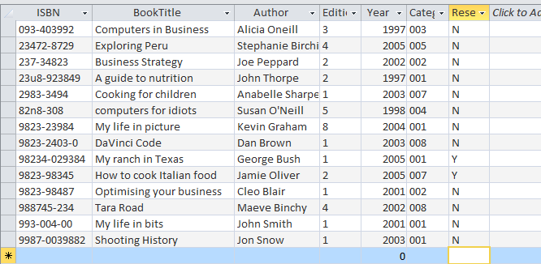

1. Category table – indicating the list of book categories (fiction, business etc). It is linked to the Books table by category code

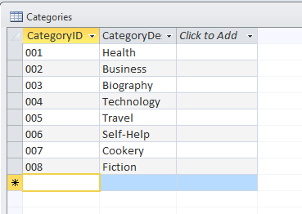

1. Reserved Books table - holding a list of books reserved by the user   
   (identified by username). It is linked to the books table by ISBN number   
   and the Users table by username.

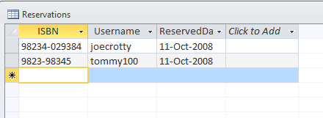

**Marking**

* The assignment carries a total of 70 marks, which is 70% of your continuous assessment mark in Web Development.
* All code must be fully tested. The examiner will not attempt to   
  debug code which does not compile or run code which is does not   
  function as required. Marks will be awarded as follows:

Completeness of functionality - 30%  
Documentation - 10%  
Coding style/readability - 10%  
Technical implementation - 20%

**Submission of Assignment**

You are required to submit **electronically** your assignment on or before the due date. The details of each are below.   
Please note the penalties of the assessment regulations for late submission.

***Electronic submission (through webcourses)***

A document that:

* lists the PHP pages used in your application – including a textual description of each page stating what the page does and how it interacts with other pages
* contains a copy listing of your source code (.php , .html) .
* contains a copy sample of each screen as it appears in   
  your application
* design document

You will be required to demonstrate your program in lab.

• **Assignment Regulation:**

This assignment is not group projects; students are expected to complete an assignment individually. Please note penalty below.

**Penalties** (except in exceptional circumstances)

1. Failure to submit an assignment will result in no marks for that element of the assessment.

2. Submission of an assignment after the due date but within one working week will result in a 50% reduction of the marks.

3. Submission of an assignment more than one working week after the due date will result in no marks.

4. Assessment components that are plagiarised will result in zero marks for all parties involved.